Lab 2

Task 1 & 2

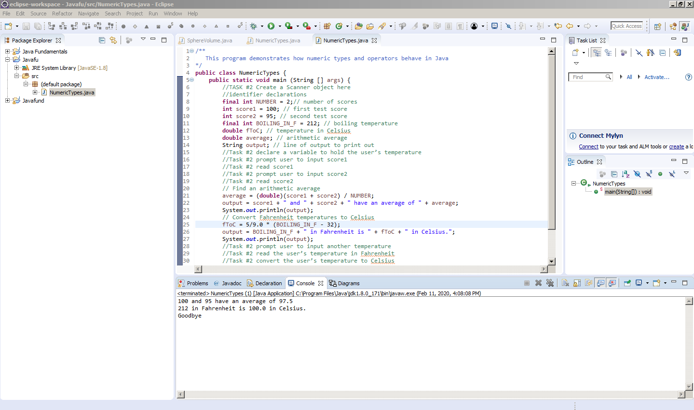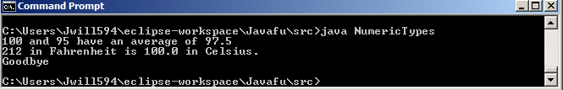

Task 3

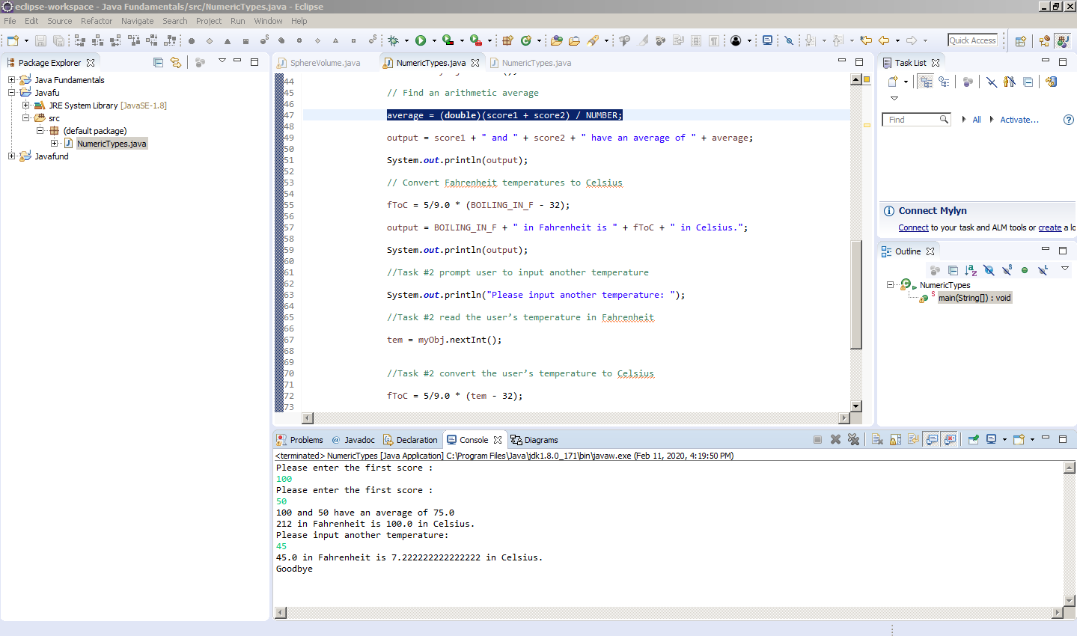

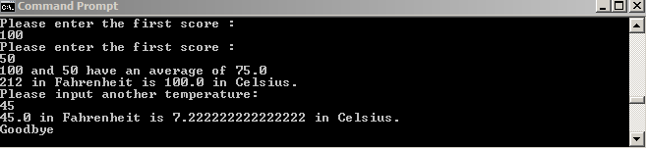

Task 4

|  |  |  |
| --- | --- | --- |
| Diameter | Volume (hand calculated) | Volume (resulting output) |
| 2 | The volume of the sphere is 4.1887902047863905. | The volume of the sphere is 4.1887902047863905. |
| 25.4 | The volume of the sphere is 8681.987647736241. | The volume of the sphere is 8681.987647736241. |
| -5 | The volume of the sphere is -65.44984694978736. | The volume of the sphere is -65.44984694978736. |

